Create A Chatbot In Python

* Phase 5
* Documenting the design thinking process and preprocessing,visualization and innovation techniques.

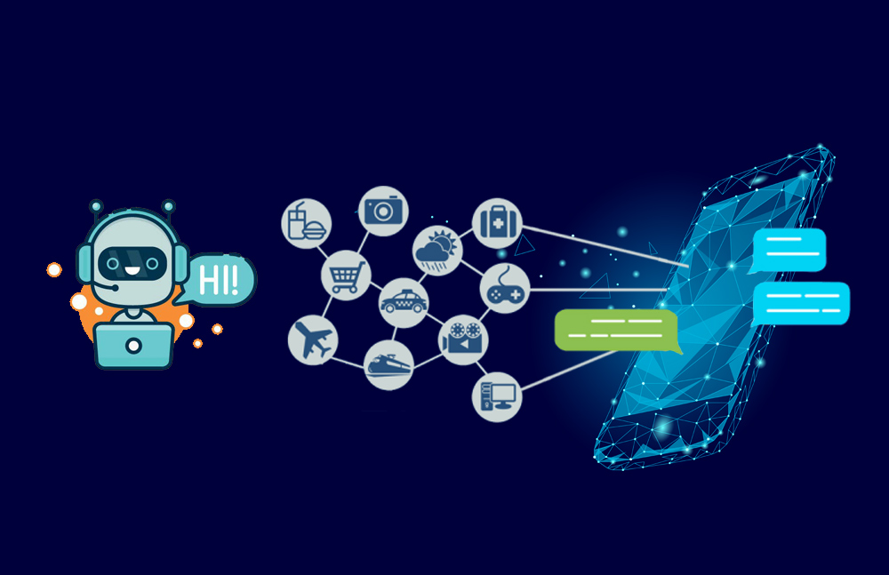

Abstract:

A chatbot is a computer software program that conducts a conversation via auditory or textual methods. This software is used to perform tasks such as quickly responding to users, informing them, helping to purchase products and providing better service to customers. Chatbots are programs that work on Artificial Intelligence (AI) & Machine Learning Platform. Chatbot has become more popular in business groups right now as it can reduce customer service costs and handles multiple users at a time. But yet to accomplish many tasks there is a need to make chatbots as efficient as possible. In this project, we provide the design of a chatbot, which provides a genuine and accurate answer for any query using Artificial Intelligence Markup Language (AIML) and Latent Semantic Analysis (LSA) withpython platform.

Introduction:

A chatbot is an automated software program that interacts with humans. A chatbot is merely a computer program that fundamentally simulates human conversations. A chatbot that functions through AI and machine learning has an artificial neural network inspired by the neural nodes of the human brain. Chatbots are programs that can do talk like human conversations very easily. For example, Facebook has a machine learning chatbot that creates a platform for companies to interact with their consumers through the Facebook Messenger application. In 2016, chatbots became too popular on Messenger. By the consequences is noted that 2016 was the entire year of chatbots. The software industry is mainly oriented on chatbots. Thousands of chatbots are invented on startups and used by the businesses to improve their customer service, keeping them hanging by a kind communication. According to research, nowadays chatbots are used to solve a number of business tasks across many industries like E-Commerce, Insurance, Banking, Healthcare, Finance, Legal, Telecom, Logistics, Retail, Auto, Leisure, Travel, Sports, Entertainment, Media and many others. Thus that was the moment to look at the chatbots as a new technology in the communication field. Nowadays various companies are using chatbots to answer quickly and efficiently some frequented asking questions from their own customers. AIML and LSA are used for creating chatbots. Artificial Intelligence Markup Language (AIML) and Latent Semantic Analysis (LSA) are used for developing chatbots, which are used to define general pattern-based queries. This pattern can also be used to give random responses for the same query in the chatbot. LSA is a Latent Semantic Analysis technology in python, which is utilized to discover likenesses between words as vector representation. So that the unanswered queries by AIML will be viewed as a reply by LSA.

Design And Thinking:

Design thinking is a human-centered approach to problem-solving and product development. Let's break down how design thinking principles can be applied to various aspects of a project, including problem definition, functionality, user interface, natural language processing (NLP), responses, integration, testing, and improvement:

1. **Problem Definition**:

- **Empathize**: Understand the needs and pain points of the users or stakeholders through research and interviews.

- **Define**: Clearly articulate the problem you're trying to solve, based on user insights and challenges identified.

2. **Functionality**:

- **Ideate**: Brainstorm potential solutions and functionalities that address the defined problem.

- **Prototype**: Create rough sketches or mockups to visualize how the functionality will work.

3. **User Interface (UI)**:

- **Prototype**: Develop high-fidelity UI designs based on user needs and preferences.

- **Test**: Gather user feedback through usability testing to refine the UI.

4. **Natural Language Processing (NLP)**:

- **Ideate**: Brainstorm ways NLP can enhance the user experience or solve specific user problems.

- **Prototype**: Create NLP models or algorithms that support the intended functionality.

5. **Responses**:

- **Test**: Ensure that NLP responses are accurate, context-aware, and align with user expectations.

- **Iterate**: Continuously refine and improve the responses based on user feedback.

6. **Integration**:

- **Ideate**: Plan how various components and systems will work together seamlessly.

- **Prototype**: Create integration models or diagrams to visualize data flow and interactions.

7. **Testing**:

- **Test**: Conduct thorough testing, including unit testing, integration testing, and user acceptance testing.

- **Iterate**: Address any issues or bugs discovered during testing.

8. **Improvement**:

- **Iterate**: Collect user feedback and data post-launch to identify areas for improvement.

- **Iterate**: Continuously refine the product, making updates and enhancements based on user needs and changing requirements.

Throughout this process, collaboration among multidisciplinary teams, including designers, developers, NLP experts, and testers, is crucial. Regular feedback loops and user involvement help ensure that the final product meets user expectations and solves the defined problem effectively. Design thinking encourages an iterative and user-centric approach, allowing for flexibility and adaptation throughout the project lifecycle.

Phases Id Development:

Developing a chatbot in Python can be broken down into several phases. Here's a high-level overview of the typical development phases:

1. *Define Objectives and Use Cases*:

- Determine the purpose of your chatbot and the problems it will solve.

- Identify specific use cases and goals.

2. *Gather Data*:

- Collect or generate data, including conversation examples, FAQs, and any relevant information.

3. *Choose a Framework or Library*:

- Select a Python framework or library for chatbot development. Popular options include NLTK, spaCy, Rasa, or using machine learning frameworks like TensorFlow or PyTorch.

4. *Natural Language Understanding (NLU)*:

- Implement NLU to understand user input. This may involve techniques like tokenization, part-of-speech tagging, and named entity recognition.

5. *Build the Dialogue System*:

- Create the core of the chatbot by defining the logic for responding to user inputs. You can use rule-based systems or machine learning-based approaches.

6. *Training*:

- If you're using machine learning, train your chatbot with the collected data to improve its language understanding and responses.

7. *Integration*:

- Integrate your chatbot with messaging platforms or the desired interface, such as a website or mobile app.

8. *Testing and Debugging*:

- Thoroughly test your chatbot, both manually and through automated tests. Debug and refine its responses.

9. *User Experience Design*:

- Ensure the chatbot provides a user-friendly experience with clear instructions and helpful responses.

10. *Deployment*:

- Deploy your chatbot to a server or cloud platform, making it accessible to users.

11. *Monitoring and Maintenance*:

- Continuously monitor and maintain the chatbot to improve its performance, address issues, and update its knowledge base.

12. *Scaling* (if necessary):

- As user demand grows, consider scaling your chatbot infrastructure to handle increased traffic.

13. *Feedback and Iteration*:

- Gather user feedback and iterate on your chatbot to enhance its capabilities and address user needs.

Remember that chatbot development is an ongoing process, and it's essential to keep improving and expanding its capabilities based on user feedback and evolving requirements.

Data Sets and data preproser steps:

Creating a chatbot in Python involves working with datasets and preprocessing the data. Here are some steps to get you started:

1. *Choose a Dataset*:

- You can start by selecting a dataset suitable for your chatbot's purpose. Common options include conversation transcripts, customer support chats, or domain-specific data.

2. *Data Preprocessing*:

- Tokenization: Split the text into words or subword tokens using libraries like spaCy, NLTK, or tokenizers.

- Lowercasing: Convert all text to lowercase to ensure uniformity.

- Remove Punctuation: Eliminate special characters and punctuation.

- Stopword Removal: Remove common words like "and," "the," "is" that don't carry much meaning.

- Stemming or Lemmatization: Reduce words to their root form to handle variations.

- Data Cleaning: Address any specific data issues in your dataset.

3. *Data Format*:

- Convert the preprocessed data into a format suitable for training a chatbot, such as a list of question-answer pairs.

4. *Text Vectorization*:

- Convert text data into numerical format. Common methods include TF-IDF (Term Frequency-Inverse Document Frequency) or word embeddings like Word2Vec, GloVe, or FastText.

5. *Training and Testing Split*:

- Divide your dataset into training and testing sets to evaluate your chatbot's performance.

6. *Building the Chatbot Model*:

- You can use libraries like TensorFlow, PyTorch, or pre-built NLP frameworks like Hugging Face Transformers to build your chatbot model.

7. *Model Training*:

- Train your chatbot model on the training data using appropriate algorithms and architectures. Sequence-to-sequence models or transformer-based models are common choices.

8. *Evaluation*:

- Evaluate your chatbot's performance on the testing data using metrics like BLEU score, perplexity, or other domain-specific metrics.

9. *Fine-tuning*:

- Based on the evaluation results, fine-tune your model to improve its performance.

10. *Deployment*:

- Once satisfied with your chatbot's performance, deploy it to your desired platform or integrate it with your application.

Remember that the success of a chatbot heavily depends on the quality of your data and the design of your model. It may require iterations of fine-tuning and improvements to achieve the desired function.

Flow Chart:

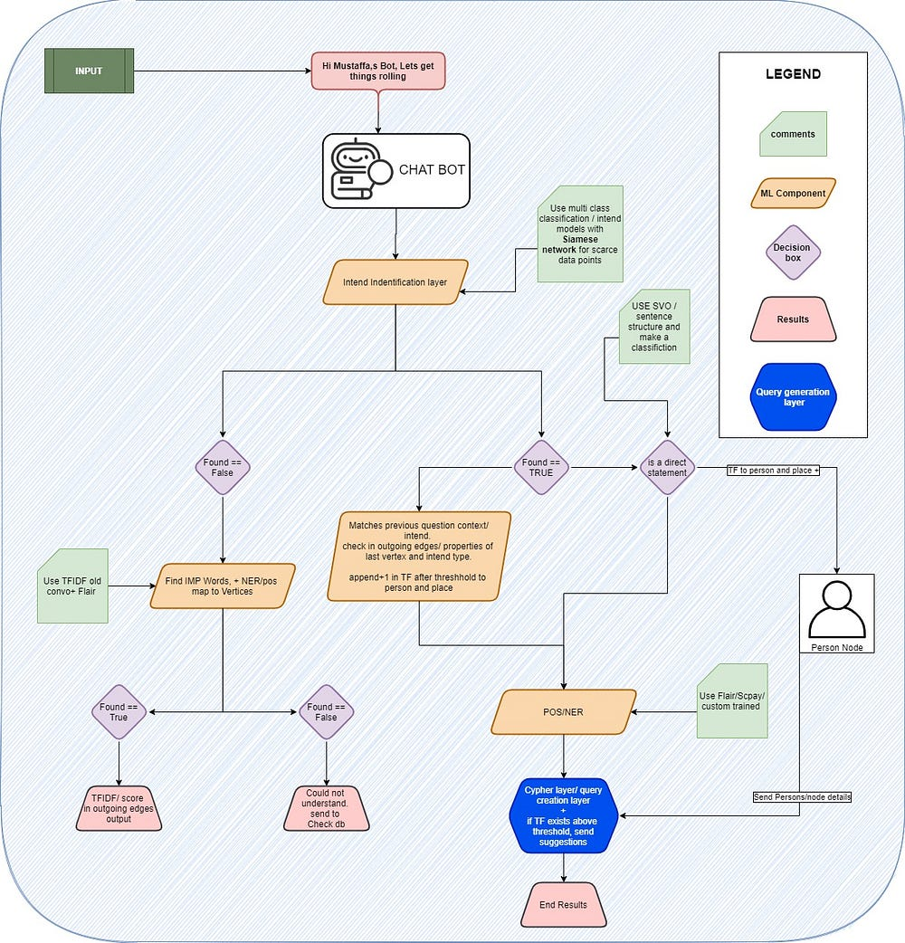

Program:

#import trunc

from math import trunc

#initialising the values

a = 20.33

b = 12.46

c = 9.54

res_sum = a + b + c

#displaying the sum value

print("The result of a + b + c is ", res_sum)

#using trunc

print("The converted value of a is: ", trunc(a))

print("The converted value of b is: ", trunc(b))

print("The converted value of c is: ", trunc(c))

print("The converted value of sum is: ", trunc(res_sum))

Output:

The result of a + b + c is 42.33

The converted value of a is: 20

The converted value of b is: 12

The converted value of c is: 9

The converted value of sum is: 42

About data:

Creating a chatbot in Python involves several key steps:

1. *Data Collection*: Gather the data you'll use to train your chatbot. This can include text data, conversation logs, or other relevant information.

2. *Data Preprocessing*: Prepare your data for training. This may involve tokenization, removing stop words, and other text cleaning techniques.

3. *Choose a Framework or Library*: Select a Python library or framework for building your chatbot. Some popular options include:

- *NLTK (Natural Language Toolkit)*: A library for natural language processing.

- *spaCy*: Another library for NLP with pre-trained models.

- *TensorFlow or PyTorch*: If you want to build more complex chatbots with neural networks.

4. *Model Selection*: Decide on the type of chatbot you want to create. This could be rule-based, retrieval-based, or generative. Choose or design a model accordingly.

5. *Training*: Train your chatbot model using the preprocessed data. The process differs depending on the chosen model type.

Visualization Techinques:

Visualizing chatbot interactions in Python can help in monitoring and improving your chatbot's performance. Here are some visualization techniques you can use:

1. *Matplotlib and Seaborn*: You can use these libraries to create various plots and charts to analyze chatbot data, such as line charts to show the number of conversations over time or bar charts to display the most common user intents.

2. *Word Clouds*: Generate word clouds to visualize the most frequently used words or phrases in user conversations. This can help you identify key topics or issues.

3. *Network Graphs*: Create network graphs to visualize how different conversations flow. Each node can represent a message or user interaction, and edges represent connections between them.

4. *Time Series Plots*: If you're collecting data over time, time series plots can help you track metrics like response times or conversation duration.

5. *Histograms*: Use histograms to visualize message length distribution in user input or chatbot responses. This can help you understand the diversity of message lengths.

6. *Pie Charts*: You can use pie charts to represent the distribution of intents or topics in user conversations.

7. *Heatmaps*: Heatmaps can be helpful for visualizing patterns in conversation data, such as the frequency of specific words or phrases across different conversations.

8. *GUI-Based Tools*: There are libraries like Dash or Streamlit that allow you to create interactive dashboards for visualizing chatbot analytics. You can build custom web-based interfaces to display various metrics and visualizations.

9. *Sentiment Analysis*: Visualize sentiment scores over time using line charts or other appropriate visualizations to see how user sentiment changes during interactions.

10. *Chatbot Flow Diagrams*: Create flow diagrams or flowcharts to visualize the logical flow of the chatbot's responses based on different user inputs.

11. *Dashboarding Tools*: Utilize dashboarding tools like Tableau or Power BI if you want to create more complex and interactive visualizations of chatbot data.

To implement these techniques, you'll need to collect and preprocess the chatbot data and then use Python libraries to create the visualizations. The choice of technique will depend on your specific goals and the data you have available.

Characteristics:

To create a chatbot in Python, you'll want to consider several key characteristics and components. Here are the fundamental characteristics for building a chatbot in Python:

1. Natural Language Processing (NLP): Your chatbot should be able to understand and process natural language. Libraries like NLTK, spaCy, or the Hugging Face Transformers can help with this.

2. User Input Processing: It should be able to process user input, which typically involves tokenization, text cleaning, and language understanding.

3. Response Generation: Your chatbot should generate coherent and contextually relevant responses. This may involve using predefined responses or machine learning models for response generation.

4. Dialogue Management: Implement a dialogue management system to maintain context and manage the conversation flow.

5. Intent Recognition: Recognize the intent of the user's messages to understand their requests or questions.

6. Entity Recognition: Extract important entities or information from user inputs, like dates, locations, or specific details.

7. Learning and Adaptation: Some chatbots can learn and adapt from user interactions, improving their responses over time.

8. Integration: Integrate with external services or APIs to provide users with useful information or perform tasks.

9. Multilingual Support: If needed, consider supporting multiple languages to make your chatbot more versatile.

10. User Experience: Focus on the user interface and user experience (UI/UX) to make the interaction more engaging and intuitive.

11. Error Handling: Implement robust error handling to gracefully handle unexpected user inputs.

12. Security: Ensure data privacy and security, especially if handling sensitive user information.

13. Scalability: Design your chatbot to handle increased usage and user loads if necessary.

You can build a chatbot using various Python libraries and frameworks, such as NLTK, spaCy, Rasa, and the Transformers library by Hugging Face. Additionally, there are cloud-based services like Dialogflow and Microsoft Bot Framework that offer chatbot development tools.

The specific characteristics and components of your chatbot will depend on its purpose and the complexity you want to achieve. It's important to plan and design your chatbot carefully to meet the requirements of your intended use case.

Performance:

To create a performant chatbot in Python, you can follow these steps:

1. *Choose a Framework*: Start by selecting a framework or library for building your chatbot. Common choices include NLTK, spaCy, TensorFlow, PyTorch, or specialized chatbot frameworks like Rasa or ChatterBot.

2. *Data Collection*: Gather a dataset for training your chatbot. This can include conversational data or specific domain-related data, depending on your chatbot's purpose.

3. *Preprocessing*: Clean and preprocess your data. Tokenization, stemming, and lemmatization are often used to prepare text data for training.

4. *Model Selection*: Decide on the architecture of your chatbot. Common choices include rule-based, retrieval-based, or generative models. You can use pre-trained models like GPT-3 or train your own.

5. *Training*: Train your model on the prepared dataset. If you're using a neural network, this may involve setting up a deep learning architecture and optimizing hyperparameters.

6. *Integration*: Integrate your chatbot into your Python application. This could be through a web interface, a command-line interface, or other methods, depending on your use case.

7. *Natural Language Understanding (NLU)*: Implement NLU components to understand user input. This can involve intent recognition and entity extraction.

8. *Dialog Management*: Implement dialog management to handle multi-turn conversations and context. This could be rule-based or using reinforcement learning techniques.

9. *Response Generation*: Generate meaningful and contextually relevant responses based on user input. This might involve using templates, machine learning, or a combination of both.

10. *Performance Optimization*: Optimize your chatbot for speed and resource usage. This may involve using techniques like batching and caching.

11. *Testing and Evaluation*: Test your chatbot rigorously. Collect user feedback and continuously improve its performance.

12. *Scalability and Deployment*: Ensure your chatbot can handle multiple users and scale if necessary. Deploy it on a server or cloud platform for real-world use.

13. *Monitoring and Maintenance*: Regularly monitor your chatbot's performance, address issues, and keep it up-to-date with the latest advancements in NLP.

Remember that the choice of framework, model, and architecture will depend on your specific requirements. Also, always consider the ethical and privacy aspects of your chatbot, especially when dealing with sensitive user data or generating responses that adhere to ethical guidelines.

Conclusion:

In this project, we have introduced a chatbot that is able to interact with users. This chatbot can answer queries in the textual user input. For this purpose, AIML with program-o has been used. The chatbot can answer only those questions which he has the answer in its AIML dataset. So, to increase the knowledge of the chatbot, we can add the APIs of Wikipedia, Weather Forecasting Department, Sports, News, Government and a lot more. In such cases, the user will be able to talk and interact with the chatbot in any kind of domain. Using APIs like Weather, Sports, News and Government Services, the chatbot will be able to answer the questions outside of its dataset and which are currently happening in the real world. The next step towards building chatbots involves helping people to facilitate their work and interact with computers using natural language or using their set of rules. Future Such chatbots, backed by machine-learning technology, will be able to remember past conversations and learn from them to answer new ones. The challenge would be conversing with the various multiple bot users and multiple users. As future work, we can make a chatbot that is based on AIML and LSA. This technology will enable a client to interact with a chatbot in a more natural fashion. We can enhance the discussion by including and changing patterns and templates for general client queries using AIML and the right response are given more often than LSA.